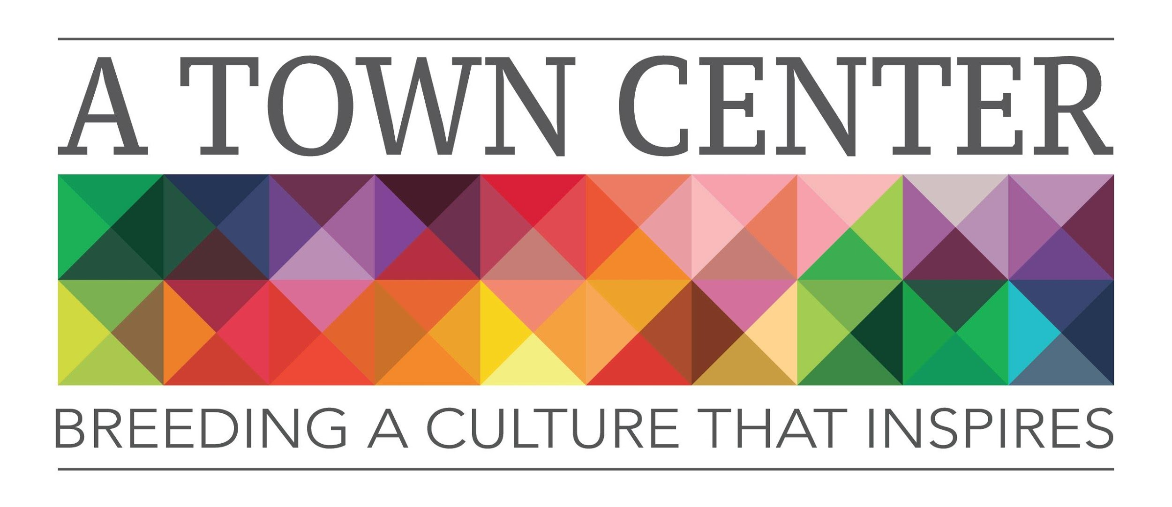
1206 Meridian Street, Anderson IN 46016
www.atowncenter.org
atowncenter@gmail.com

A Town Center, Inc. is seeking artists interested in participating in its Artists-in-Residence program. The Program, a component of the program was designed to give free space to artists or groups of artists if they give back to the community in one or more of the following ways:
- Community Event- i.e. Festival
- Teaching Community Workshops @ A Town Center, Inc. on Saturdays
- First Friday Event- Musical talent, food creation, etc.
In turn, the artist will get the opportunity to showcase their work on display at A Town Center, Inc. They will also have the ability to sell pieces of work at the studio. The artists will also be featured on the website, Facebook and any media that is sent out to promote A Town Center, Inc.
A Town Center, Inc. will connect its artist with the community to encourage arts integration and strengthen arts education.
A Town Center’s Board of Directors will collect applications, resumes and background check authorizations and select artists for the program. We are looking for artists who express a genuine passion for art, community engagement and increasing the Quality of Life in Anderson Indiana.

A Town Center, Inc.’s goal is to identify 4-6 artists in the areas of visual art, dance, music, culinary arts or other art forms. Once artists are chosen, artists will be contacted.
We are excited to hear from you and are open to any creative input.
Residency is based on 1 year. After your year is up and you have successfully completed your project, you are available to apply again for another year with another project or an extension/ continuation of your current project.
Thank you for your consideration, Keep Creating!
A Town Center Inc. Board of Directions
Program Direction- Sonia Caldwell
Artistic Director- Levi Rinker
President- Marisa Kelly-Rigney
Treasurer- Kim Rogers-Hatfield
Secretary- Evan Williams
Rebekah Dugan
Ed Paul Fry
Michele Hockwalt
Katherine Kester

Artist in Residence FAQ’s
- A Town Center, Inc. is seeking artists with a passion for visual arts, dance, music, culinary arts or other art forms. (Not limited)
- Artists who apply are not guaranteed to be placed in the program.
- Selected artists must attend a mandatory orientation program the week following their interview. TBA
- Selected artist will be required to submit a short biography and photo and are encouraged to promote themselves and their project. More information will be provided at orientation.
- Artists are encouraged to serve their residency for the duration of the project. Artists have full access to their space 24 hours a day unless a tenant moves into the adjacent space and times/terms will be renegotiated with option to end lease.
- Artists who complete their residence will be required to submit a project evaluation as well as participate in an end- of-project round table discussion.
- Artists are required to decorate their own space to fit their needs. Any structural changes must be approved with the Board of Directors.
- Mutual space (gathering area, hallways in the artist area) can be decorated with mutual collaboration from current artists in residence.
- Smoking is prohibited in the building.
- Overnight guests are prohibited as well as continual use of the space as an “apartment”. We understand that each individual’s hours and creative time will vary.
- Quiet times are encouraged and expected Sunday-Thursday 11:00 p.m.- 6:00 a.m.
- Minimum use of 40 HOURS PER MONTH for the space is required. If you aren’t using the space, you will be asked to give up your studio and let another artist move in. Minimum hours are set to build community amongst artists and create a creative, conducive environment. Collaboration and energy cannot take place in empty rooms!
- Artists are to attend 10/12 First Friday Events.
- To apply as an Artist in Residence, please fill out and return the Artist-in-Residence application and background check authorization. You may also submit a resume. It is suggested that you apply by e-mail to atowncenter@gmail.com
- Interviews will be held at A Town Center, Inc. located @ 1206 Meridian Street Anderson IN 46016. There is free parking on Meridian Street or the city lot adjacent to the YMCA.
- Please plan on arriving ten minutes before your scheduled interview to accommodate parking and restroom needs.
- Please wear attire you would choose to wear for your residency.
- Please bring any displays, pictures, finished works and anything else you see fit that can help us envision an Artist-in-Residence project plan. You should also bring two forms of identification to process you background check.
- We would like to know about your materials, techniques, and your objective of the project.
- Applicants will be notified within seven days from their interview.
- Any interview or residency questions should be directed to Sonia Caldwell, Program Director, at atowncenter@gmail.com
Applications will be accepted until spaces are filled. Thank you!

