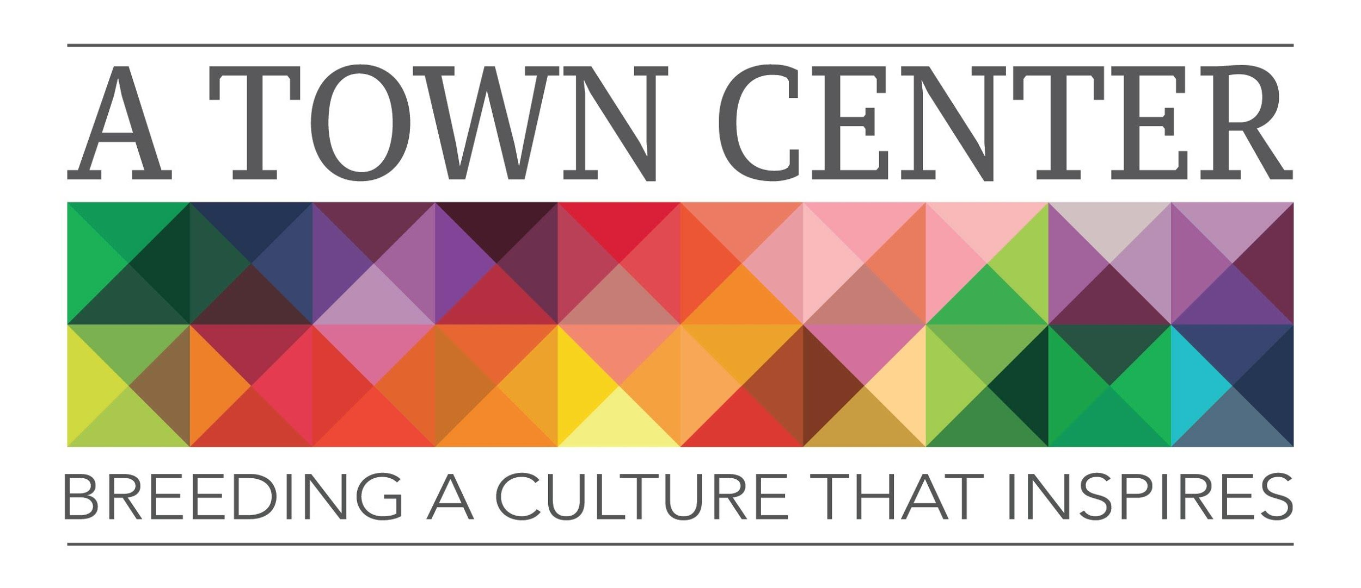
Dear Patron of the Arts,
A Town Center, Inc. is a 501(c) 3 not-for-profit organization, whose board of directors is dedicated to bringing the arts and education to our community.

A Town Center Inc. is a cooperative art studio, art gallery, and community art space located at 1206 Meridian Street in the Historic Diamond Building in downtown Anderson, Indiana. Our mission is to breed a culture that inspires growth both economically and interpersonally through programming geared towards community engagement and artistic achievement. We want to see A Town Center and downtown Anderson continue to thrive and become known as a destination for arts and culture, specialty retail shopping, food and dining, entertainment, festivals, and special events.

We currently host the Downtown First Friday Art Walks, Third Thursday Open Mic Poetry Nights, Wine and Canvas events, Cookies and Canvas classes, Kids Art Camps, 1-on-1 Pottery lessons, and other Creative Art classes taught by artists in residence and other guest artists. We are hosting a “Movies That Matter” film series, Movie Nights, as well as Yoga, Meaningful Meditation Classes, and Y12SR (Yoga/12 Step Recovery) classes in our space. Our artists in residence receive free studio space at A Town Center, Inc. for one year in exchange for their giving back to the community in the form of art workshops, donation of gallery pieces, participating in community festivals, or leading community art and engagement projects. Attached you will see some of the programs and projects we have already championed out of A Town Center, Inc.
In order to see the ARTS thrive in our community, we would like to offer you the opportunity to become a patron of A Town Center, Inc. We need your support to host these types of programs, give artist-in-residency spots, scholarship kids classes, and be of service to everyone in our community. Please take a moment to consider each of the tax deductible levels below and donate with a passion!
Imaginative $1000+
Innovative $500-$999
Inventive $250-$499
Productive $100-$249
Expressive $25-$99

Additionally, we hope that you come by and see us, our doors are open!

Sincerely,
Sonia Caldwell, Program Director
On Behalf of the Board of Directors

THANKS AGAIN FOR SUPPORTING YOUR LOCAL ARTS ORGANIZATIONS

Your gift is a contribution to a not-for-profit corporation, recognized by the Internal Revenue Service as tax exempt. Your donation is fully tax-deductible to the extent allowed by law.
All gifts will be listed in A Town Center, Inc. printed programs, online media, website and at A Town Center for the 2019-2020 Season (June 2019-May 2020).

Please make checks payable to A Town Center, Inc.
Please include your name, address, phone and email.

BUSINESS or FAMILY NAME
Contact Name
ADDRESS
CITY/STATE/ZIP
PHONE
EMAIL
SPONSORSHIP AMOUNT
Artwork | Please provide your company logo or artwork in a suitable electronic version to the email above.

Please ensure that your company or Family name is provided as you would like it listed in all print work.

- A Town Center, Inc. Patron Level- Imaginative ($1000+) includes logo and special mention on our website and social media promotion, logo on display at A Town Center, Inc., 4 free passes to any of the monthly art classes and exclusive invitation to Behind the Scenes event with the artists in residence and VIP tickets to special receptions for Art Gallery Opening Nights.

- A Town Center, Inc. Patron Level - Innovative ($500-999) includes logo and special mention on our website and social media promotion, 4 free passes to any of the monthly art classes and exclusive invitation to Behind the Scenes event with the artists in residence and VIP tickets to Art Gallery Opening Nights.

- A Town Center, Inc. Patron Level Inventive ($250-499) includes logo on our website and social media promotion and 4 free passes to any monthly art class.

- A Town Center, Inc. Patron Level – Productive ($100-249) includes special mention on our website and social media promotion and 2 free passes to any of the monthly art classes.

- A Town Center, Inc. Patron Level - Expressive ($25-99) includes special mention on our website and social media promotion.

