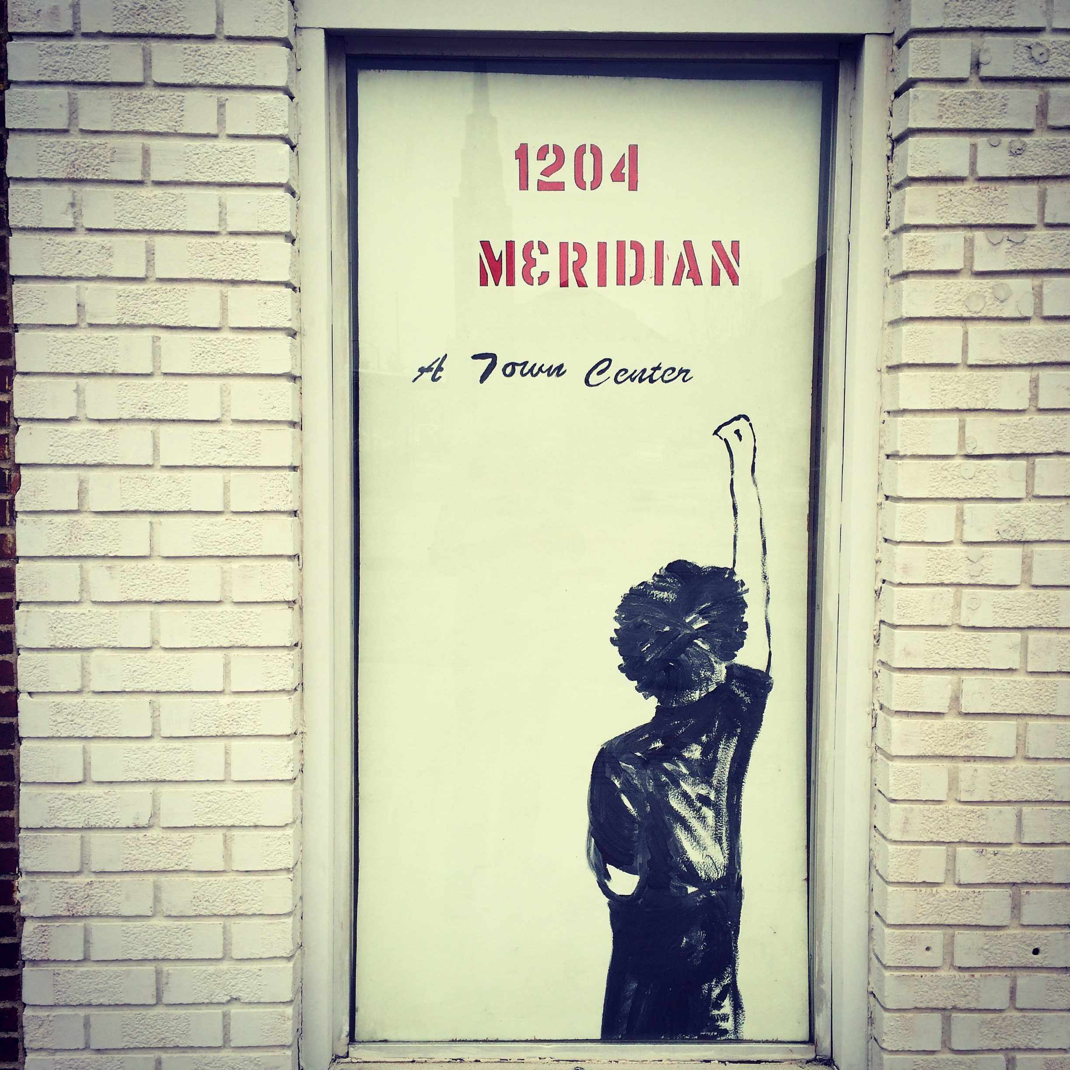 | A Town Center, Inc.  1204 Meridian Street  Anderson, IN 46016  www.atowncenter.org  (765) 203-1127  atowncenter@gmail.com
Dear Patron of the Arts,
I would like to introduce you to A Town Center Inc., a cooperative art space, art gallery and community art space, located in Anderson, Indiana. Under the Artistic Direction of Levi Rinker and Program Director Sonia Caldwell, A Town Center, Inc. is in its planning phase in both programming and upgrades to the facility at 1204 Meridian Street which is the North Side of the Historic Diamond Building Downtown Anderson. A Town Center Inc. wants to be a location to create an atmosphere for change and have positive community impact. We want to breed a culture that inspires growth both economically and interpersonally through programming geared towards community engagement and artistic achievement. We want to see our A Town Center, Downtown Anderson, thrive and become known as a destination for arts, culture, specialty retail shopping, food and dining, festivals, entertainment and special events. We will host First Fridays, Open Mic Nights for performing arts and musicians, Saturday workshops including art classes taught by artists in residence as well as guest artists, movie nights with guest chefs and up and coming chefs and entrepreneurs in both craft beer, wine and food. Our artists in residence will receive free space at A Town Center, Inc. for one year in exchange for their giving back to the community in the form of art workshops, gallery pieces, community festivals or community art and engagement projects. Attached you will see some of the programs and projects that have already come out of A Town Center, Inc. A Town Center, Inc. is a not-for-profit organization 501(c) 3, whose board of directors is dedicated to bringing the arts and education to our community.
We want to see that the ARTS continue to thrive in our community. In order to do so, A Town Center, Inc. needs your support. We are currently fundraising with this campaign to upgrade the facilities to have legal occupancy and to support the programs we are planning. We would like to offer you the opportunity to become a patron of the arts, by supporting the continuation of these programs and have a facility to support the growth of the arts open to everyone in our community. Take a moment to donate to A Town Center, Inc. by purchasing a “Patron Ad or Listing”. Your name/business will be listed by category in our program for all classes, openings and events at A Town Center, Inc. as well as in our social media and website and on location at 1204 Meridian Street, A Town Center, Inc.
Imaginative $1000+
Innovative $500-$999
Inventive $250-$499
Productive $100-$249
Expressive $25-$99

Additionally, we hope that you come by and see us, our progress or even help with the renovation process!

Sincerely,
Sonia Caldwell
Program Director, Board of Directors
A Town Center, Inc.
1204 Meridian Street, Anderson, IN 46016

THANKS AGAIN FOR SUPPORTING YOUR LOCAL ARTS ORGANIZATIONS
Your gift is a contribution to a not-for-profit educational corporation, recognized by the Internal Revenue Service as tax exempt. Your donation is fully tax-deductible to the extent allowed by law.
All gifts will be listed in A Town Center, Inc. printed programs, online media, website and at A Town Center for the 2017 Season.

Please make checks payable to A Town Center, Inc.
Please include your name, address, phone and email.

BUSINESS or FAMILY NAME
Contact Name
ADDRESS
CITY/STATE/ZIP
PHONE
EMAIL
SPONSORSHIP AMOUNT
Artwork | Please provide your company logo or artwork in a suitable electronic version to the email above.

Please ensure that your company or Family name is provided as you would like it listed in all print work.

- A Town Center, Inc. Patron Level- Imaginative ($1000+) includes logo and special mention on our website, logo in print at A Town Center, Inc. a full page color advertisement in programs for Art Exhibits and Special Events at A Town Center, Inc., free participation in Behind the Scenes events with the artists in residence, invitations to Art Gallery Opening Nights, and special introduction at each event for the year. This option also includes a free season pass to the Saturday Workshops and special invite to exclusive A Town Center, Inc. events.

- A Town Center, Inc. Patron Level - Innovative ($500-999) includes logo on our website, logo in print at A Town Center, Inc., logo included in programs for Art Exhibits and Special Events at A Town Center, Inc., 4 free passes to a Saturday Workshop class and free participation in Behind the Scenes events with the artists in residence and invitations to Art Gallery Opening Nights.

- A Town Center, Inc. Patron Level Inventive ($250-499) includes logo on our website, logo in print at A Town Center, Inc., logo included in programs for Art Exhibits and Special Events at A Town Center, Inc. and 4 free passes to a Saturday Workshop class.

- A Town Center, Inc. Patron Level – Productive ($100-249) includes special mention on our website, name in print at A Town Center, Inc. and 2 free passes to a Saturday Workshop Class.

- A Town Center, Inc. Patron Level - Expressive ($25-99) includes special mention on our website and in print at A Town Center, Inc.

