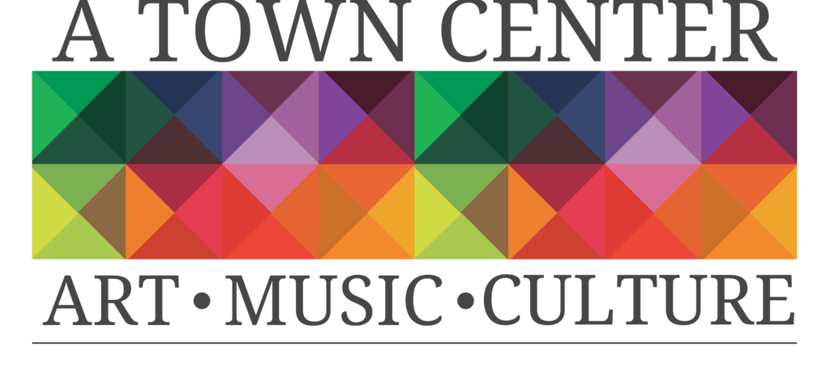
Dear Patron of the Arts,
A Town Center, Inc. is a 501(c) 3 not-for-profit organization, whose board of directors is dedicated to bringing the arts and education to our community.

A Town Center Inc. is a cooperative art studio, art gallery, and community art space located at 1206 Meridian Street in the Historic Diamond Building in downtown Anderson, Indiana. Our mission is to create a culture that inspires growth both economically and interpersonally through programming geared towards community engagement and artistic achievement. We want to see A Town Center and downtown Anderson continue to thrive and become known as a destination for arts and culture, specialty retail shopping, food and dining, entertainment, festivals, and special events.

We host the downtown First Friday Art Walk, Third Thursday Open Mic Poetry Night, wine and canvas events, cookies and canvas classes, Kids Art Camp, and other creative art classes taught by artists in residence and guest artists, plus movies and more.

Our artists in residence receive free studio space at A Town Center, Inc. for one year in exchange for giving back to the community in the form of art workshops, donation of gallery pieces, participation in community festivals, or leading community art and engagement projects.
We hope you will consider becoming a patron of A Town Center, Inc. We need your support to host these important programs that improve the quality of life in our community. Please take a moment to consider each of our tax-deductible patron levels.
Imaginative $1000+
Innovative $500-$999
Inventive $250-$499
Productive $100-$249
Expressive $25-$99

We hope that you come by and see us!

Sincerely,
Sonia Caldwell, President, Board of Directors

Your gift is a contribution to a not-for-profit corporation, recognized by the Internal Revenue Service as tax exempt. Your donation is fully tax-deductible to the extent allowed by law.
All gifts will be listed in A Town Center, Inc. printed programs, online media, website and at A Town Center for the applicable season.

Please make checks payable to A Town Center, Inc.
Please include your name, address, phone and email.

BUSINESS or FAMILY NAME
Contact Name
ADDRESS
CITY/STATE/ZIP
PHONE
EMAIL
SPONSORSHIP AMOUNT
Artwork | Please provide your company logo or artwork in a suitable electronic version to the email above.

Please ensure that your company or family name is provided as you would like it listed in all print work.

- A Town Center, Inc. Patron Level- Imaginative ($1000+) includes logo and special mention on our website and social media promotion, logo on display at A Town Center, Inc., four free passes to any of the monthly art classes, exclusive invitations to behind the scenes events with artists in residence, and VIP tickets to special receptions.

- A Town Center, Inc. Patron Level - Innovative ($500-999) includes logo and special mention on our website and social media promotion, four free passes to any of the monthly art classes, exclusive invitations to behind the scenes events with artists in residence, and VIP tickets to special receptions.

- A Town Center, Inc. Patron Level Inventive ($250-499) includes logo on our website and social media promotion and four free passes to any monthly art class.

- A Town Center, Inc. Patron Level – Productive ($100-249) includes special mention on our website and social media promotion and two free passes to any of the monthly art classes.

- A Town Center, Inc. Patron Level - Expressive ($25-99) includes special mention on our website and social media promotion.

